**A**



**PROJECT REPORT**

ON

**“A FRAMEWORK TO MAKE VOTING SYSTEM TRANSPARENT USING**

**BLOCK CHAIN TECHNOLOGY”**

Submitted for the degree of

**Bachelor of Computer Engineering**

**BY**

Jadhav Gaurav Vijay ROLL NO. 26

Desale Aakash Laxman ROLL NO. 19

Sawardekar Nitesh Namdev ROLL NO. 50

**UNDER THE GUIDANCE OF**

DR. SHITAL AGRAWAL

**DEPARTMENT OF COMPUTER ENGINEERING**

**SHIVAJIRAO S. JONDHLE COLLEGE OF ENGINEERING AND**

**TECHNOLOGY,**

**ASANGAON.**

UNDER UNIVERSITY OF MUMBAI

2023-24

**DECLARATION**

This is to certify that the project report entitled **“A FRAMEWORK TO MAKE**

**VOTING SYSTEM TRANSPARENT USING BLOCK CHAIN TECHNOLOGY”**

which is submitted by the project members in partial fulfilment of the requirement for the

award of degree B.E in computer engineering to Mumbai University, Mumbai comprises only

the original work and due acknowledgement has been made in the text to all other material

used.

**Date:**

**Name of the Students:**

GAURAV VIJAY JADHAV

AAKASH LAXMAN DESALE

NITESH NAMDEV SAWARDEKAR

**PROJECT CO-ORDINATOR**

PROF. VISHAL SHINDE

**CERTIFICATE**

This is to certify that Project Report entitled **“A FRAMEWORK TO MAKE**

**VOTING SYSTEM TRANSPARENT USING BLOCK CHAIN TECHNOLOGY”**

which is submitted by project members in partial fulfilment of the requirement for the award

of degree B.E in computer engineering to Mumbai University is a record of the candidates

own work carried out by him/her under my supervision.The matter embodied in this thesis is

original and has not been submitted for the award of anyother degree.

**Date:**

**Name of the Students:**

GAURAV VIJAY JADHAV

AAKASH LAXMAN DESALE

NITESH NAMDEV SAWARDEKAR

**Name of the Guide:** DR. SHITAL AGRAWAL

**Sign and Date:**

DR. SHITAL AGRAWAL

**(Internal Examiner) (External Examiner**

PROF. VISHAL SHINDE DR. MRS. GEETHA K. JAYARAJ

**HOD Principal,**

**Department of Computer Engg. SSJCET, Asangaon**

**ACKNOWLEDGEMENT**

This is great pleasure and immense satisfaction to express our deepest sense of gratitude

and thanks to everyone who has helped us in completing our work successfully. We are

presenting this Project report on **“A FRAMEWORK TO MAKE VOTING SYSTEM**

**TRANSPARENT USING BLOCK CHAIN TECHNOLOGY”** as part of the curriculum

of B.E. Computer Engineering. Inspiration and guidance are invaluable in every aspect of

life especially in the field of academics, which we have received from our respected **Project**

**Guide:** Dr. Shital Agrawal and **Head of Computer Department:** Prof. Vishal R. Shinde.

Besides, we take this opportunity to express our sincere gratitude to the **Principal:** Dr. Mrs.

Geetha K. Jayaraj, SSJCET, for providing a good environment and facilities to complete

this project. We would also like to thank all our staff and friends who have directly or

indirectly guided andhelped us in the preparation of this report and also for giving us

unending support rightfrom the stage this idea was conceived.

GAURAVVIJAY JADHAV

AAKASH LAXMAN DESALE

NITESH NAMDEV SAWARDEKAR

i

**LIST OF PUBLICATIONS**



Paper Published in International Journal for Research in Engineering Application & Management

(IJREAM) With Paper-ID: in Special Issue I Create on **“A FRAMEWORK**

**TO MAKE VOTING SYSTEM TRANSPARENT USING BLOCK CHAIN TECHNOLOGY”**

In April 2024.

ii

**ABSTRACT**

*The Indian voting system is now inefficient and open to outside interference. Voter ID cards are the*

*only thing that are subject to security checks, and these days, many people can fake them. It is*

*sluggish and can take time to hand count the votes. Polling booths are taken and most ballots are*

*frequently destroyed in certain remote regions with no security. The main goal is to address issues*

*with both conventional and digital elections, including any form of error or unfairness that may have*

*occurred during the election process. To make sure a fair election and mitigate unfairness, the voting*

*process can employ blockchain technology. To cut down on repetition and inconsistency, electronic*

*voting has gradually replaced paper-based voting. It is possible to introduce a new voting system*

*that acquires login and requires both the candidate's name and a face verification. It's a web*

*application that works with each kind of browser. The name, photo, and other information of eligible*

*voters will be stored in the state or district government database, if deemed appropriate. Thus, only*

*eligible voters will be capable to cast ballots thanks to trained data. Additionally, this program makes*

*sure that voting is anonymous. Each user is assigned a random block chain address after logging in,*

*which is unrelated to their personal information. As a result, it is impossible to determine which user*

*voted for which candidate. Even voters without literacy will benefit from the straightforward, user-*

*friendly interface that is in use [1].*

***Keywords*** *-* ***e-voting, Blockchain technology , KNN, Face-detection, Transparency, Cryptographic***

***Identity.***

iii

**CONTENTS**

**Certificate……………………………………………...………………………………**

**Acknowledgement……………………………………...…………..…………………. i**

**List of Publications…..………………………………………………………………… ii**

**Abstract…………..……………………………………………………………………. iii**

**Contents……………...………………………………………………………………… iv**

**List of Figures……....…….……………………………………...……………………. vi**

**List of Tables…….………………………………………………………………..…… vii**

**Abbreviations………….……………………………………………...……................. viii**

**1. INTRODUCTION AND MOTIVATION**

1.1 Introduction ………………………………………………………………………. 1

1.2 Aims and objectives…………………………………………………….………….. 2

1.3 Existing system……………………………………………..................................... 3

1.4 Limitations on Existing System…………………………………………………... 4

1.5 Proposed System………………………………………………………………….. 5

**2. PROJECT REVIEW**

2.1 Literature Survey……….…………………………………………………………. 6

2.1.1 Comparative Analysis …………………….………………………………. 9

2.1.2 Mathematical Model ……………………………………………………………….. 10

2.2 Problem Statement ……………………………………………….……………….. 14

2.3 System Overview……………………………………………………………..…… 15

2.4 Project Timeline Chart……………………………………………………………. 16

2.5 Task Distribution………………………………………………………………….. 17

2.5.1 Design Phase……………………………………………………………….. 17

2.5.2 Implementation Phase………………………………………………………. 17

**3. SOFTWARE REQUIREMENT SPECIFICATION**

3.1 Hardware Specification…………………………………….……………………… 18

3.2 Software Specification………………………………………………….…………. 18

iv

**4. SYSTEM DESIGN**

4.1 Design Specification…………………………….……………….…………..…... 19

4.2 System Architecture………………………………………………………...……. 22

4.3 Data Flow Diagram (DFD)……………………………………………………….. 23

4.4 Flow Chart Diagram……………………………………………............................ 27

4.5 UML Diagrams……………………………………………................................... 28

4.5.1 Class Diagram…………………………………………….......................... 28

4.5.2 Sequence Diagram………………………………………........................... 29

4.5.3 Use Case Diagram ………………………………………...……………… 30

4.5.4 Activity Diagram…………………………….............................................. 31

4.5.5 Collaboration Diagram …………………………………………………… 32

**5. PROJECT IMPLEMENTATION**

5.1 Technology Overview……………..……………………………………………... 33

5.2 Coding….……………………………..…………………………………………… 35

**6. TESTING**

6.1 System Testing…..…………………………………............................................... 40

6.1.1 Manual test..…………………………………………...…………………… 40

**7. RESULTS AND DISCUSSIONS**

7.1 Result sets…………………….…………..…………………………….................. 41

7.2 Screenshots………………………………...……………………………................. 44

**8. ADVANTAGES**……………………………..……….……………………………. 46

**CONCLUSION**………………………………….…………………………………... 47

**FUTURE WORK**……………………………….…………………………………… 48

**REFERENCES ………………………………………………………….…………...** 49

**APPENDIX**

v

**LIST OF FIGURES**

**Fig No. Name of Figure Page No.**

2.4 Project Timeline Chart 16

4.2 System Architecture for e-Voting Syatem 22

4.3.1 DFD Level 0 for e-Voting System 23

4.3.2 DFD Level 1 for e-Voting System 24

4.3.3 DFD Level 2 for e-Voting System 25

4.3.4 DFD Level 3 for e-Voting System 26

4.4 Flow Chart 27

4.5.1 Class Diagram 28

4.5.2 Sequence Diagram 29

4.5.3 Use Case Diagram 30

4.5.4 Activity Diagram 31

4.5.5 Collaboration Diagram 32

7.2.1 Home Page 44

7.2.2 Face Verification 44

7.2.3 Casting Vote 45

vi

**LIST OF TABLES**

**Table No. Table Name Page No**

2.1.1 Comparative Analysis of Existing System 9

2.5.1 Design Phase 16

2.5.2 Implementation Phase 16

6.1 Test Cases 39

7.1.1 Testing Performance on Train Set 1 40

7.1.2 Testing Performance on Train Set 2 42

7.1.2 Testing Performance on Train Set 2 43

vii

**LIST OF ABBREVATIONS**

**Abbrevation Description**

PCA Principal Component Analysis

CNN Convolutional Neural Networks

ANN Artificial Neural Network

DS-DSA Deep Stacked Denoising Sparse Autoencoders

DFD Data Flow Diagram

AI Artificial Intelligence

DL Deep Learning

KNN K- Nearest Neighbors

viii

**INTRODUCTION**

**AND**

**MOTIVATION**

A Framework To Make Voting System Transparent Using Block Chain Technology



r

**1. INTRODUCTION & MOTIVATION**

**1.1 INTRODUCTION**

Counting hands was the first voting method, and it has since been replaced by paper,

punch cards, mechanical levers, and optical scan devices. Modern electronic voting systems

have a few characteristics that set them apart from more antiquated methods. They also offer

better features than those methods, including mobility, accuracy, privacy, ease, adaptability,

and verifiability. However, electronic voting methods have several problems, such being

time-consuming, requiring a lot of paper labor, not involving senior officials directly, causing

machine damage from neglect, preventing users from editing and updating many items at

once, and so on. Thus, user can avoid data loss by putting in place a decentralized Blockchain-

based server infrastructure. Using blockchain technology to hold a digital election lowers the

possibility of voting-related unfairness while simultaneously saving costs. Modern

technologies, like as blockchain technology, possess a high degree of security, and offer

significant advantages when employed with caution. The implementation of this

technology as the potential to enhance the transparency, reliability, and Monitoring of voting

systems [1]. A current voting system involves a voting machine connected to a central

database. This machine can be interfered with by anyone who has access to it. It may cause a

single point failure in the entire voting system network; but an immutable blockchain cannot

be altered by an individual traitor in the entire network.[8]

SSJCET, Asangaon 1 Department of Computer Engg.

A Framework To Make Voting System Transparent Using Block Chain Technology



**1.2 AIM AND OBJECTIVE**

**AIM**

Introducing a new electronic voting system with face verification that will address the

shortcomings of the country's current voting practices.[1]

**OBJECTIVE**

The key objectives of the project include:

➢ The election system must be openly verifiable and transparent.

➢ The election system must ensure that the vote cast by the voter has been recorded.

➢ Only eligible voters must be allowed to vote.

➢ The election system should be tamper-proof.

➢ No power-hungry organization must be able to manipulate and rig the election process.

SSJCET, Asangaon 2 Department of Computer Engg.

A Framework To Make Voting System Transparent Using Block Chain Technology



**1.3 EXISTING SYSTEM**

This is the current voting system used in India. In this system vote is cast using electronics ballet.

In this we cast our vote in an electronics machine. This is a group of some counter and registers.

This voting system is quite easy, simple. It has advantage like mobility, secure, flexibility for

election commission. But in today world all people are so much busy that they don’t have time to

vote. This paper presents a perspective in the electronic voting process. That includes but not limited

to identifying the polling process, The polling process the actual voting process used on the polling

day.

**Blockchain setup**

To satisfy the privacy and security requirements for e-voting, and to ensure that the election system

should not enable coerced voting, voters will have to vote in a supervised environment. In our work,

we set up a Go-Ethereum permissioned Proof-of-Authority (POA) blockchain to achieve these

goals. POA uses an algorithm that delivers comparatively fast transactions through a consensus

mechanism based on identity as a stake. The reason for using Go-Ethereum for the blockchain

infrastructure is explained in sub-section C. The structure of the blockchain is illustrated in Figure

1 and mainly consists of two types of nodes.

Verifying votes In the voting transaction, each voter receives the transaction ID of his vote. In this

e-voting system, voters can use this transaction ID and go to an official election site (or authority)

using a blockchain explorer and (after authenticating themselves using their electronic

identification) locate the transaction with the corresponding transaction ID on the blockchain.

Voters can, therefore, see their votes on the blockchain, and verify that the votes were listed and

counted correctly. This type of verification satisfies the transparency requirements while preventing

traceability of votes.

SSJCET, Asangaon 3 Department of Computer Engg.

A Framework To Make Voting System Transparent Using Block Chain Technology



**1.4 LIMITATIONS ON EXISTING SYSTEM**

The problems of the existing manual system of voting include among others the following:

• **Expensive and Time consuming:** The process of collecting data and entering this data

into the database takes too much time and is expensive to conduct, for example, time and

money is spent in printing data capture forms, in preparing registration stations together

with human resources, and there after advertising the days set for registration process

including sensitizing voters on the need for registration, as well as time spent on entering

this data to the database.

• **Too much paper work:** The process involves too much paper work and paper storage

which is difficult as papers become bulky with the population size.

• **Short time provided to view the voter register:** This is a very big problem since not all

people have free time during the given short period of time to check and update the voter

register.

SSJCET, Asangaon 4 Department of Computer Engg.

A Framework To Make Voting System Transparent Using Block Chain Technology



**1.5 PROPOSED SYSTEM**

The system that is suggested is the face verified online e-voting system with Face Verification using

KNN algorithm and identification of voter using Block chain Address [2]. The Blockchain address

is used to determine whether a particular voter is valid or not. It enables a particular voter to cast their

ballot online. The polling procedure keeps going until the voting period is over, updating the server's

database. Block chain addresses are used by the Face Verification online voting method to obtain all

of the voter's personal information [3]. Additionally, the votes are publicly accessible and kept on a

blockchain server, guaranteeing a reliable environment. When a voter inquiries to vote, the VMS,

checks the voter's voting status on the blockchain through contrasting all existing transaction hashes

with his or her computerized ID (Ethereum address). If a transaction's hash has been determined

against the voter's ID, VMS rejects the request and logs the voter out of the system.[1]

**ADVANTAGES OF PROPOSED SYSTEM:**

• Voter can cast their votes from anywhere in the country without visiting to voting booths, in

highly secured way.

• This will increase the voting percentage in India and reduces the cost of voting process.

• By using Face Verification it provides enough security which reduces the false votes.

• The collection of the results is done from the stored data on the blocks through the significant

organization of the nodes in the block chain.

**Algorithm**: KNN, SHA-256

SSJCET, Asangaon 5 Department of Computer Engg.

**PROJECT OVERVIEW**

A Framework To Make Voting System Transparent Using Block Chain Technology



**2. PROJECT OVERVIEW**

**2.1 LITERATURE SURVEY**

**Paper 1**

**Paper Name:** Secure E-Voting System using Block-chain technology and authentication via

Face recognition and Mobile OTP

**Authors Name:** Q. Zhang, Palapye, Botswana

**Year of Publish: 2022**

**Explanation:**

A distributed ledger is used in blockchain which store data, making it an essential part of

democracy. Web-based voting systems have evolved, making them available to all citizens,

including those in rural areas. Voting ensures that each citizen has a say in a country's legislation,

while decentralized systems such as blockchain ensure that transactions are linked to previous

ones. The miners mine on the blockchain and get paid for their efforts. To ensure security,

blockchain-based voting systems employ a decentralized chain of blocks linked by nodes, each

containing a cryptographic hash, timestamp, and exchange information. A proposed solution is

to store voting-related information on the blockchain and monitor users throughout the vote-

taking process, with a Face Recognition System to ensure they are verified and eligible to vote.[2]

SSJCET, Asangaon 6 Department of Computer Engg.

A Framework To Make Voting System Transparent Using Block Chain Technology



**Paper 2**

**Paper Name:** Blockchain-Based E-Voting System

**Authors Name:** Hjálmarsson, Gunnlaugur K. Hreidarsson, Mohammad Hamdaqa **Year of Publish : 2018**

**Explanation**:

A secure electronic voting system that offers the fairness and privacy of current voting schemes,

while providing the transparency and flexibility offered by electronic systems has been a

challenge for a long time. In this work-in-progress paper, evaluate an application of blockchain

as a service to implement distributed electronic voting systems. The paper proposes a novel

electronic voting system based on blockchain that addresses some of the limitations in existing

systems and evaluates some of the popular blockchain frameworks for the purpose of

constructing a blockchain-based e-voting system. In particular, the paper evaluates the potential

of distributed ledger technologies through the description of a case study; namely, the process of

an election, and the implementation of a blockchain based application, which improves the

security and decreases the cost of hosting a nationwide election[6].

SSJCET, Asangaon 7 Department of Computer Engg.

A Framework To Make Voting System Transparent Using Block Chain Technology



**Paper 3**

**Paper Name:** Improved Face Recognition Rate Using HOG Features and SVM Classifier

**Authors Name:** Harihara Santosh Dadi, Gopala Krishna Mohan Pillutla

**Year of Publish : 2019**

**Explanation:**

A novel face recognition algorithm is presented in this paper. Histogram of Oriented Gradient

features are extracted both for the test image and also for the training images and given to the

Support Vector Machine classifier. The detailed steps of HOG feature extraction and the

classification using SVM is presented. The algorithm is compared with the Eigen feature based

face recognition algorithm. The proposed algorithm and PCA are verified using 8 different

datasets. Results show that in all the face datasets the proposed algorithm shows higher face

recognition rate when compared with the traditional Eigen feature based face recognition

algorithm. There is an improvement of 8.75% face recognition rate when compared with PCA

based face recognition algorithm. The experiment is conducted on ORL database with 2 face

images for testing and 8 face images for training for each person. Three performance curves

namely CMC, EPC and ROC are considered. The curves show that the proposed algorithm

outperforms when compared with PCA algorithm[7].

SSJCET, Asangaon 8 Department of Computer Engg.

A Framework To Make Voting System Transparent Using Block Chain Technology



**2.1.1 Comparative Analysis**

***Table 2.1.1 Comparative Analysis of Existing System***

**Paper Title Author Year Publication Description**

|  |  |  |  |  |  |  |  |  |  |  |  |  |  |  |  |  |  |
| --- | --- | --- | --- | --- | --- | --- | --- | --- | --- | --- | --- | --- | --- | --- | --- | --- | --- |
|  | A Framework to  Make Voting  System  Transparent Using  Blockchain  Technology | | |  | Muhammad  Shoaib Farooq,  Usman Iftikhar,  Adel Khelif |  | | 2022 | | | |  | IEEE Blockchain based e-voting  system with Ethereum  blockchain network,SHA-  256 algorithm and face  recognition with KNN. | | | | |
|  | Secure E-Voting  System using  Block-chain  technology and  authentication via  Face recognition  and Mobile OTP |  | A. Parmar, S.  Gada, T. Loke,  Y. Jain, S.  Pathak and S.  Patil | | | |  | | 2021 |  | 12th  International  Conference  on  Computing  Communicati  on and  Networking  Technologies  (ICCCNT) | | |  | Blockchain, a distributed  ledger, is crucial for  democracy and web-based  voting systems, ensuring  citizens have a say in  legislation. Decentralized  systems like blockchain  link transactions and ensure  security. A proposed  solution is to store voting-  related information on the  blockchain and monitor  users with a Face  Recognition System.. | | |
|  | E-Voting using  Blockchain |  | Yash Dalvi,  Shivam Jaiswal,  Pawan Sharma | | | |  | | 2021 |  | International  Journal of  Engineering  Research &  Technology | | |  | An overview of the  blockchain's fundamental  properties and architecture  in respect to electronic  voting. | |
|  | Improved Face  Recognition Rate  Using HOG  Features and SVM  Classifier |  | Harihara  Santosh Dadi,  Gopala Krishna  Mohan Pillutla | | | |  | | 2019 |  | Iosr Journal  Of  Electronics  And  Communicati  on  Engineering  (Iosr-Jece) | | |  | This paper presents an  improved face recognition  algorithm using HOG  features and SVM  classification,  outperforming traditional  methods by achieving an  8.75% higher recognition  rat. |

SSJCET, Asangaon 9 Department of Computer Engg.

A Framework To Make Voting System Transparent Using Block Chain Technology



**2.1.2 MATHEMATICAL MODEL**

Creating a mathematical model for the K-Nearest Neighbors (KNN) algorithm in a face-verified

voting system based on blockchain involves defining the key components of the system. Here's a

simplified mathematical model:

**1**. **Data Representation**:

- Each voter's face data is represented as a feature vector, denoted as \(X_i\), where \(i\) represents

the voter's index.

2. **Data Preprocessing**:

- Normalize and preprocess the feature vectors to ensure consistency. Let \(X_i\) be the

preprocessed feature vector.

3. **Training Data:**

- The system uses a dataset of labeled facial biometric data to train the KNN algorithm.

4. **KNN Algorithm**:

- Given a new voter's feature vector \(X_{new}\) and a parameter \(K\) (number of nearest

neighbors), the KNN algorithm finds the \(K\) nearest neighbors to \(X_{new\), denoted as

\(N_{KNN}\).

5. **Similarity Measure**:

- Define a similarity measure, \(S(X_i, X_j)\), between two feature vectors \(X_i\) and \(X_j\). The

choice of similarity measure depends on the nature of your data (e.g., Euclidean distance for

numerical features, cosine similarity for embeddings).

6. **Nearest Neighbors**:

- Find the \(K\) nearest neighbors by ranking all voters based on the similarity measure: \[N_{KNN} = \text{argmin}_{X_i} \sum_{X_j \in \text{Training Data}} S(X_{new}, X_j)\]

7. **Voting Decision**: - Aggregate the votes from the \(K\) nearest neighbors to determine the votingdecision. For example, if the neighbors are classified as 'Verified' or 'Not Verified,' the majority voteamong neighbors could be the decision.

8. **Blockchain Integration:**

- Integrate the voting decision into the blockchain-based voting system, recording the voter'sdecision and the verification process.

9. **Decision Threshold**:

- You may set a decision threshold for the KNN algorithm, indicating how many of the \(K\)neighbors must vote 'Verified' for the new voter to be 'Verified.'

SSJCET, Asangaon 10 Department of Computer Engg.

A Framework To Make Voting System Transparent Using Block Chain Technology



**Mathematical Formulation:**

The mathematical model for the KNN algorithm in this context involves defining the similarity

measure, which can vary based on the features used. For instance, if using the Euclidean distance

as the similarity measure for numerical feature vectors, it can be defined as:

\[S(X_i, X_j) = \sqrt{\sum_{k=1}^{n} (X_{i_k} - X_{j_k})^2}\]

Where \(n\) is the dimensionality of the feature vectors, and \(X_{i_k}\) and \(X_{j_k}\) are the

\(k\)-th components of the vectors \(X_i\) and \(X_j\).

The decision threshold may be a value indicating the maximum acceptable distance or a specific

number of neighbors required to vote 'Verified.'

This mathematical model serves as a conceptual framework.

In a face-verified voting system based on blockchain, the SHA-256 (Secure Hash Algorithm 256-

bit) is used for securing and hashing critical data, such as voter identities and voting records. Here's

a simplified mathematical model for the SHA-256 algorithm in this context:

**SHA-256 algorithm**

**1. Data Representation:**

Data, such as voter identities and voting records, is represented as a binary string or bytes. Let's

denote this data as *D*.

**2. SHA-256 Algorithm:**

The SHA-256 algorithm takes the binary data *D* as input and computes a fixed-length 256-bit hash

value *H*:

*H*=SHA-256(*D*)

**3. Mathematical Formulation:**

The SHA-256 algorithm processes the input data *D* in blocks and performs several bitwiseoperations, rotations, and modular additions. The details of the algorithm are quite complex but canbe summarized mathematically as follows:

*H*=SHA-256(*D*)=SHA-256(*D*0,*D*1,*D*2,…,*Dn*)

Where *D*0,*D*1,*D*2,…,*Dn* are the blocks of data.

The SHA-256 algorithm operates on each block using a series of logical functions, modularadditions, bitwise shifts, and constants. It transforms the input data into the 256-bit hash *H*.

**4. Security and Properties:**

The SHA-256 algorithm is designed to have several important properties, including:

**Deterministic**: The same input data will always produce the same hash value.

**Pre-image resistance**: It should be computationally infeasible to reverse the hash function to find

SSJCET, Asangaon 11 Department of Computer Engg.

A Framework To Make Voting System Transparent Using Block Chain Technology



the original input data from its hash.

**Collision resistance**: It should be highly improbable that two different inputs produce the same

hash value.

**Avalanche effect**: A small change in the input should result in a significantly different hash value.

**Efficiency**: The algorithm should be computationally efficient, making it difficult to find two

different inputs with the same hash value (a collision).

These properties ensure that the SHA-256 hash is a secure and reliable way to represent data in a

tamper-evident manner on a blockchain.

**1. User Registration & Trained Voter Face:**

User should register in our website *(User Voting Page Way)* Block chain as an initial step with their

mobile name, email, aadhar id, Voter id , image Area, Block chain Address contact number to which

an unique *USER-ID* register. Users who are all registered in this portal are also considered as voter.

The voter image convert to trained image After registering successfully the admin verify the voter

details, after user can login into their profile using their *USER-ID* and their registered password.

**Admin:**

Admin Login page with default user name and password. Admin can accept or reject an

voter request by verifying the user detail and also admin can register another admin. User has to

scan his aadhar card for verification process. After scanning he should enter his detail and send an

request to the admin if the account get rejected due to some reason he will be intimated to register

again by admin.

**2. Create Election**

The Admin can create an election with election type and election constituency. All theelection gets triggered at the given date and time. And Verified user has to login and scan his Blockchain Address if election and user constituency matches user can view Election details. And Blockchain Address. To create Nominated account in block chain.

**3. Voting**

Voters must have access to any web browser to take part in voting. The voter's interface would beprovided in English language to make it easy to use for all users. The proposed system can containa large number of voters at the time of voting. A decentralized block chain system enables a voterto vote from any part of the world. A person can take part in voting from anywhere, even if he is ina foreign country, in this way his/her computerized National ID is verified from the nationaldatabase so he can cast the vote. User has to face his registered finger during his

SSJCET, Asangaon 12 Department of Computer Engg.

A Framework To Make Voting System Transparent Using Block Chain Technology



registration process. In voting page voter has to scan his face if the User Face matches with

registered Face , voter can cast his or her vote to the right candidate Source KNN an algorithm for

recognition of human face is used to compare two Face. Voting transactions are sent to a pool from

which miners analyze them and remove the malicious request by taking the consensus from the

other nodes before adding it to the chain. The votes are fully secured using a cryptographic hash.

Each vote cast adds a new block in the chain. When the transaction completes and a node is

successfully added to Vote Chain, the voter of that particular voting transaction is notified through

an SMS to his registered email. The voter has provided with a unique transaction hash by which he

can verify his vote through a web portal and upon successfully completion of transaction the vote

has been counted in the whole voting activity.

**4. Publish Result**

Smart contracts are providing a secure connection between the user and the network while

executing a transaction in the chain. These are the rules that are implemented on the entire Block

chain and cannot be neglected under any condition. All the nodes have to follow the smart contracts

to save the vote in the system successfully. When user completes his or her voting process votes are

stored in Block chain. So the voter can trust his votes stored in block chain cannot be changed. User

can view his or her vote in a pie chart retrieved from block chain.SHA256 algorithm has been used

to hash the data. Admin Can publish the result of each constituency after the election process is fully

completed.

SSJCET, Asangaon 13 Department of Computer Engg.

A Framework To Make Voting System Transparent Using Block Chain Technology



**2.2 PROBLEM STATEMENT**

Creating a robust facial recognition system that can accurately verify a voter's identity, ensuring

that each eligible voter can only cast one vote and minimizing the potential for impersonation or

fraud. Employing blockchain technology to establish an immutable and transparent ledger for

recording votes. This ledger must be resistant to tampering and allow for public verification of the

results, enhancing trust in the election process. Employing blockchain technology to establish an

immutable and transparent ledger for recording votes. This ledger must be resistant to tampering and

allow for public verification of the results, enhancing trust in the election process[1].

SSJCET, Asangaon 14 Department of Computer Engg.

A Framework To Make Voting System Transparent Using Block Chain Technology



**2.3 SYSTEM OVERVIEW**

•**User** :

User should register in our website *(User Voting Page Way)* Block chain as an initial step with

their mobile name, email, aadhar id, Voter id , image Area, Block chain Address contact number

to which an unique *USER-ID* register. Users who are all registered in this portal are also

considered as voter. The voter image convert to trained image After registering successfully the

admin verify the voter details, after user can login into their profile using their *USER-ID* and

their registered password

•**Admin:**

Admin Login page with default user name and password. Admin can accept or reject an voter

request by verifying the user detail and also admin can register another admin. User has to scan

his aadhar card for verification process. After scanning he should enter his detail and send an

request to the admin if the account get rejected due to some reason he will be intimated to

register again by admin.

•**Create Election**

The Admin can create an election with election type and election constituency. All the election

gets triggered at the given date and time. And Verified user has to login and scan his Block

chain Address if election and user constituency matches user can view Election details. And

Block chain Address. To create Nominated account in block chain.

•**Publish Result**

➢ Smart contracts are providing a secure connection between the user and the network while

executing a transaction in the chain. These are the rules that are implemented on the entire

➢ Block chain and cannot be neglected under any condition. All the nodes have to follow the

smart contracts to save the vote in the system successfully. When user completes his or her

voting process votes are stored in Block chain. So the voter can trust his votes stored in block

chain cannot be changed. User can view his or her vote in a pie chart retrieved from block

chain.SHA256 algorithm has been used to hash the data. Admin Can publish the result of each

constituency after the election process is fully completed[1].

SSJCET, Asangaon 15 Department of Computer Engg.

A Framework To Make Voting System Transparent Using Block Chain Technology

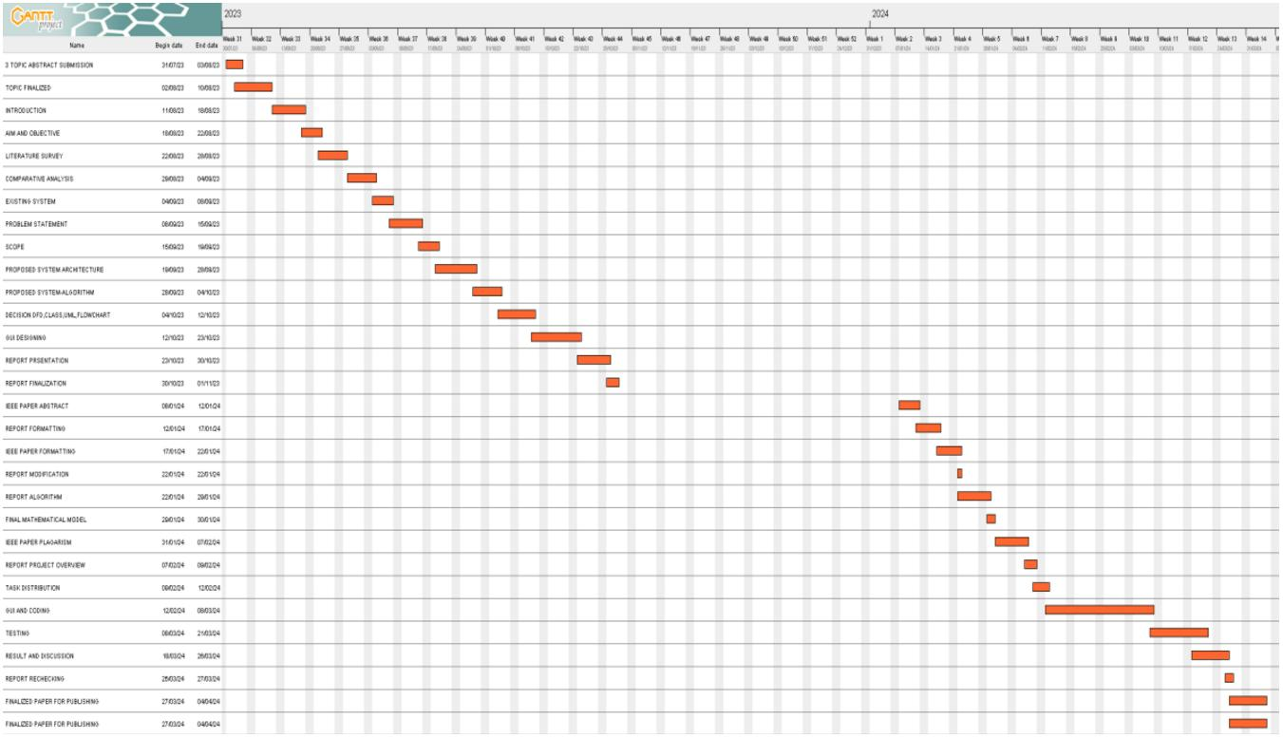

**2.4 PROJECT TIMELINE CHART**

***Fig.2.4 Project Timeline Chart***

SSJCET, Asangaon 16 Department of Computer Engg.

A Framework To Make Voting System Transparent Using Block Chain Technology



**2.5 TASK DISTRIBUTION**

**2.5.1 DESIGN PHASE**

***Table No 2.5.1: Design Phase***

**Name of Student Task Performed Result**

**Gaurav V. Jadhav** Project Design Completed Successfully

**Aakash L. Desale** Suggested Appropriate Completed Successfully

contents

**Nitesh N. Sawardekar** Documentation Completed Successfully

**2.5.2 IMPLEMENTATION PHASE**

***Table No 2.5.2****:* ***Implementation Phase***

**Name of Student Implementation Task Result**

**Gaurav V. Jadhav** Project Implementation Completed Successfully

**Aakash L. Desale** Implemented Project Completed Successfully

Algorithm.

**Nitesh N. Sawardekar** Documentation Completed Successfully

SSJCET, Asangaon 17 Department of Computer Engg.

**SOFTWARE**

**REQUIRMENT**

**SPECIFICATION**

A Framework To Make Voting System Transparent Using Block Chain Technology



**3. SOFTWARE REQUIREMENT SPECIFICATION**

**3.1 HARDWARE REQUIREMENTS**

System : Intel Core i3 2.00 GHz.

Hard Disk : 1 TB.

Monitor : 14’ Color Monitor.

Mouse : Optical Mouse.

Ram : 4 GB.

Keyboard : 101 Keyboard Keys.

**3.2 SOFTWARE REQUIREMENTS**

Operating system : Windows 10 and above.

Coding Language : Python

Software’s used : eclipse IDE, Python 3.6.3

XAMPP, Ganache.

Languages Used : JavaScript, HTML, CSS, PHP, Python, Solidity

Technology Used : Blockchain

Algorithms : SHA-256,

KNN (K-NEAREST NEIGHBOURS)

SSJCET, Asangaon 18 Department of Computer Engg.

**SYSTEM DESIGN**

A Framework To Make Voting System Transparent Using Block Chain Technology



**4. SYSTEM DESIGN**

**4.1 DESIGN SPECIFICATION**

**4.1.1 ALGORITHM**

**Step 1: Start**

**Step.2: Face Recognition using k-nearest neighbors**

def predict(self, X):

y_pred = [self._predict(x) for x in X]

return np.array(y_pred)

def _predict(self, x):

distances = [euclidean_distance(x, x_train) for x_train in self.X_train]

k_indices = np.argsort(distance)[:self.k]

k_nearst_labels = [self.y-train[i] for i in k_indies]

most_common= np.bincount(k_nearest_labels).argmax()

return most_common

**Step 3: Voter Registration using Blockchain address**

Require: Initialization of parameters

Initialize voter id = this voter_id

Initialize voter name = this voter_name

Func (Register Voter)

Input: voter id

Require: voter_id =! Null

If voter_id exist

then revert back to voter id else

if voter_age < 18

then revert back to voter id else

Add Voter successfully

End Func

End Smart Contract

SSJCET, Asangaon 19 Department of Computer Engg.

A Framework To Make Voting System Transparent Using Block Chain Technology



**Step 4: Voter identification Vote casting using SHA-256:**

mapping(address => Voter) public voters;

event Voted(adress indexed voter, uint256 vote);

function vote(uint256 _vote) public {

require(!voters[msg.sender].hasVoted, "Voter has already voted");

voters[msg.sender].hasVoted = true;

voters[msg.sender].vote = _vote;

emit Voted(msg.sender, _vote);}

**Step 5 : Stop**

SSJCET, Asangaon 20 Department of Computer Engg.

A Framework To Make Voting System Transparent Using Block Chain Technology



**4.1.2 WORKING OF ALGORITHM**

The general idea of working of proposed system algorithm is given as bellows:

Step 1: Start

This is just the beginning of the algorithm, indicating the start of the process.

Step 2: Face Recognition using k-nearest neighbors

This step involves face recognition using the k-nearest neighbors algorithm. The algorithm

predicts the label of a given input image by finding the k nearest images in the training dataset

and taking a majority vote among their labels.

Step 3: Voter Registration using Blockchain address

This step involves registering a voter using a blockchain address. It seems to define a smart

contract that initializes parameters such as voter ID and name, and then provides a function to

register a voter by checking if the ID exists and if the age is above 18. If the conditions are

met, the voter is successfully added to the registry.

Step 4: Voter identification and Vote casting using SHA-256

This step utilizes blockchain technology for voter identification and vote casting. It defines a

mapping between addresses and voters in a smart contract. The vote function allows a voter

to cast their vote by specifying their choice. It checks if the voter has already voted, records

their vote, and emits an event indicating the vote.

Step 5: Stop

This marks the end of the algorithm.

SSJCET, Asangaon 21 Department of Computer Engg.

A Framework To Make Voting System Transparent Using Block Chain Technology

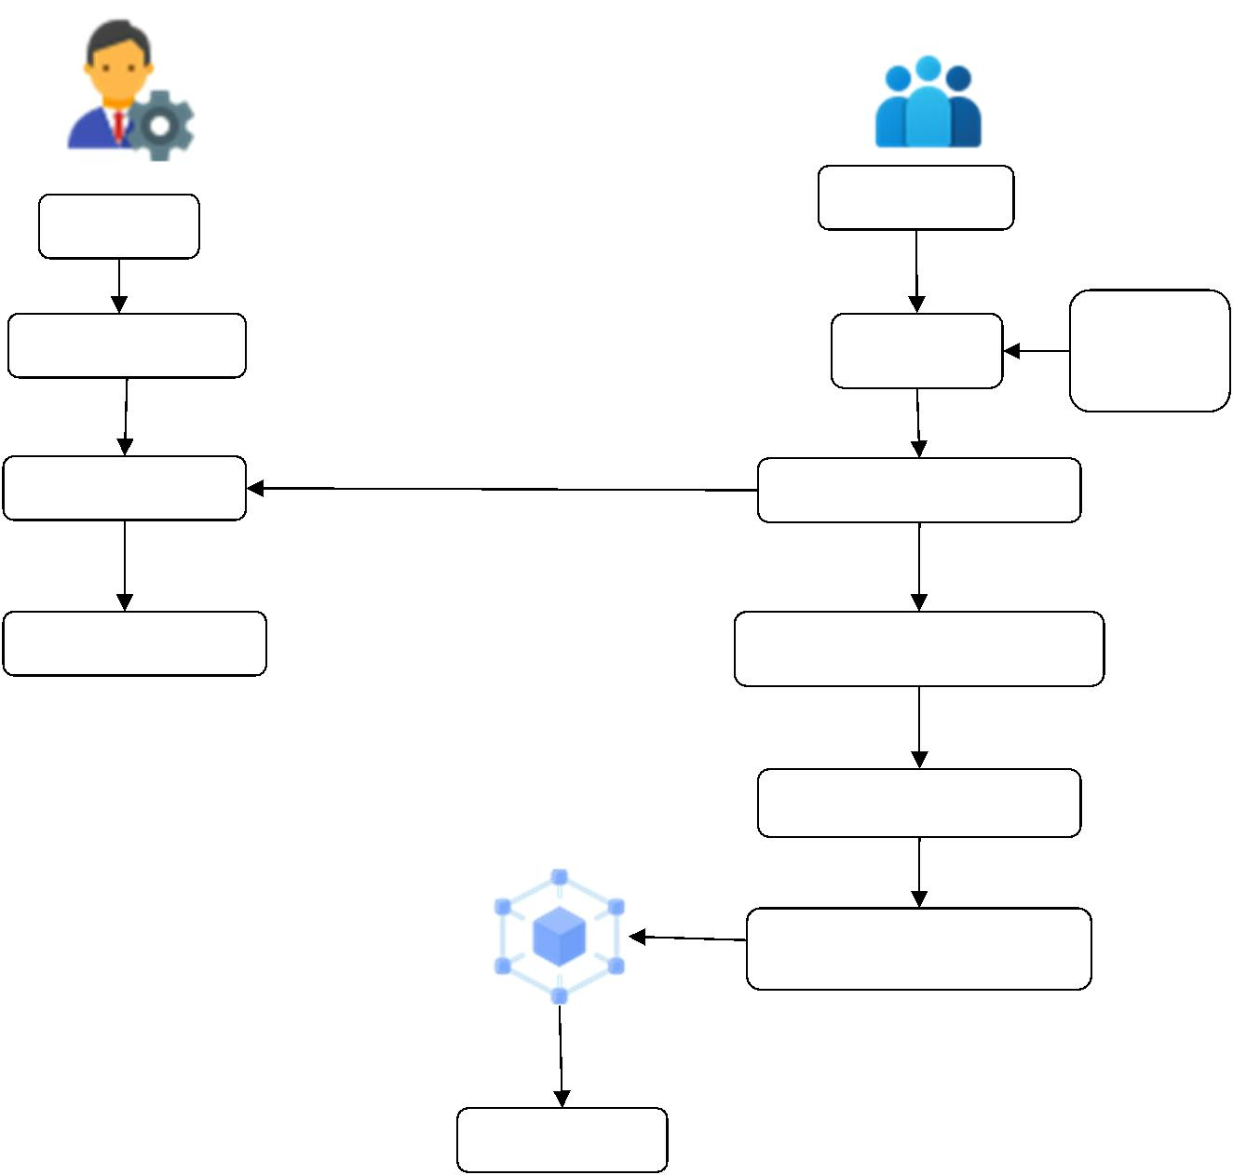

**4.2 SYSTEM ARCHITECTURE**

**User**

**Admin**

|  |  |  |  |  |  |
| --- | --- | --- | --- | --- | --- |
|  | **Add Election** |  | **Registe** |  | **Uploa**  **d** |

**Verify User Trained Image**

**Publish Result Vote for Candidate**

**Face Veriﬁcation**

**Register Vote**

**Result**

***Fig.4.2: System Architecture for e-Voting System***

SSJCET, Asangaon 22 Department of Computer Engg.

A Framework To Make Voting System Transparent Using Block Chain Technology

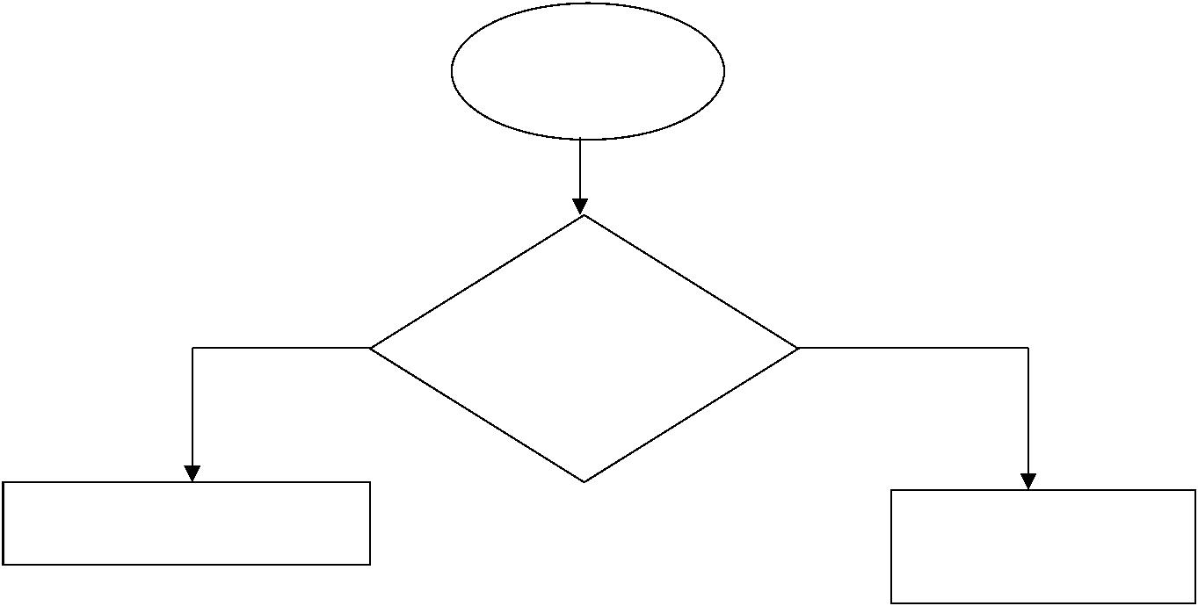

**4.3 DATA FLOW DIAGRAM**

Verify for block chain

Check if already

voted or not

|  |  |  |  |
| --- | --- | --- | --- |
|  | Display voter’s info |  | Display warning  message |

***Fig. 4.3.1: DFD Level 0 for e-Voting System***

SSJCET, Asangaon 23 Department of Computer Engg.

A Framework To Make Voting System Transparent Using Block Chain Technology

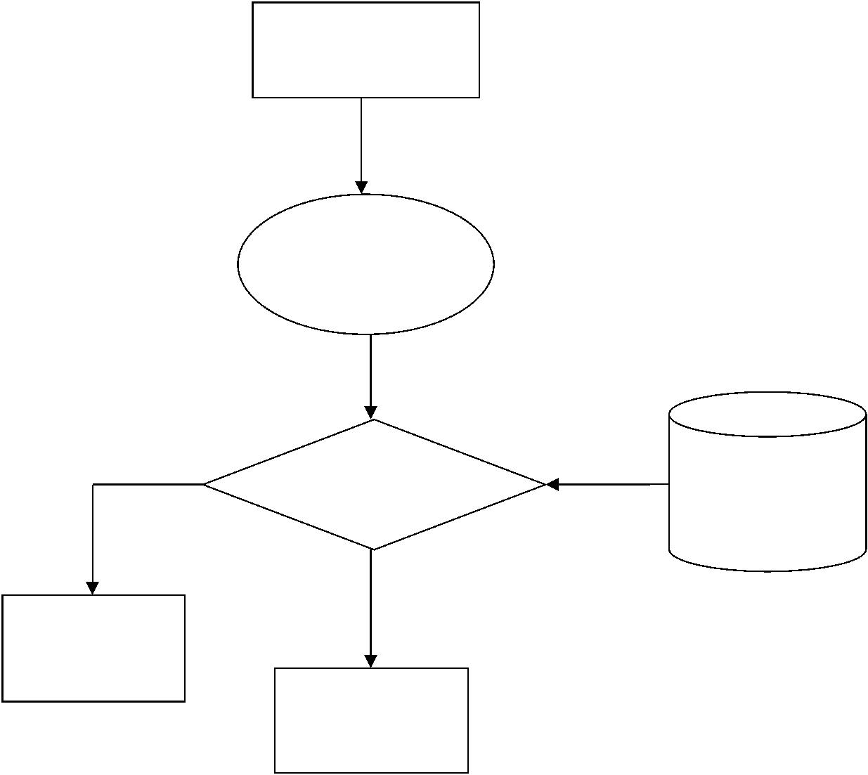

Voter’s Details

Scanning Face

Comparison Face veriﬁcation in

block chain

Displaywarning

Voting process

***Fig. 4.3.2: DFD Level 1 for e-Voting System***

SSJCET, Asangaon 24 Department of Computer Engg.

A Framework To Make Voting System Transparent Using Block Chain Technology

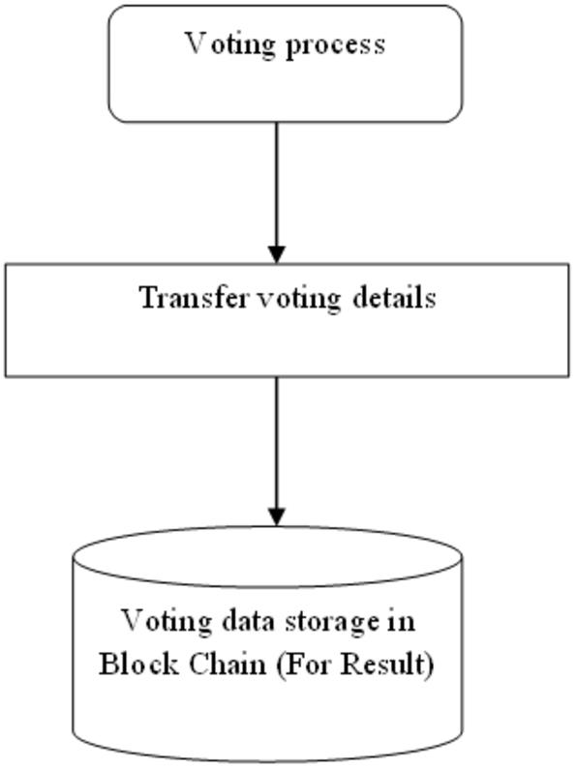

***Fig. 4.3.3: DFD Level 2 for e-Voting System***

SSJCET, Asangaon 25 Department of Computer Engg.

A Framework To Make Voting System Transparent Using Block Chain Technology

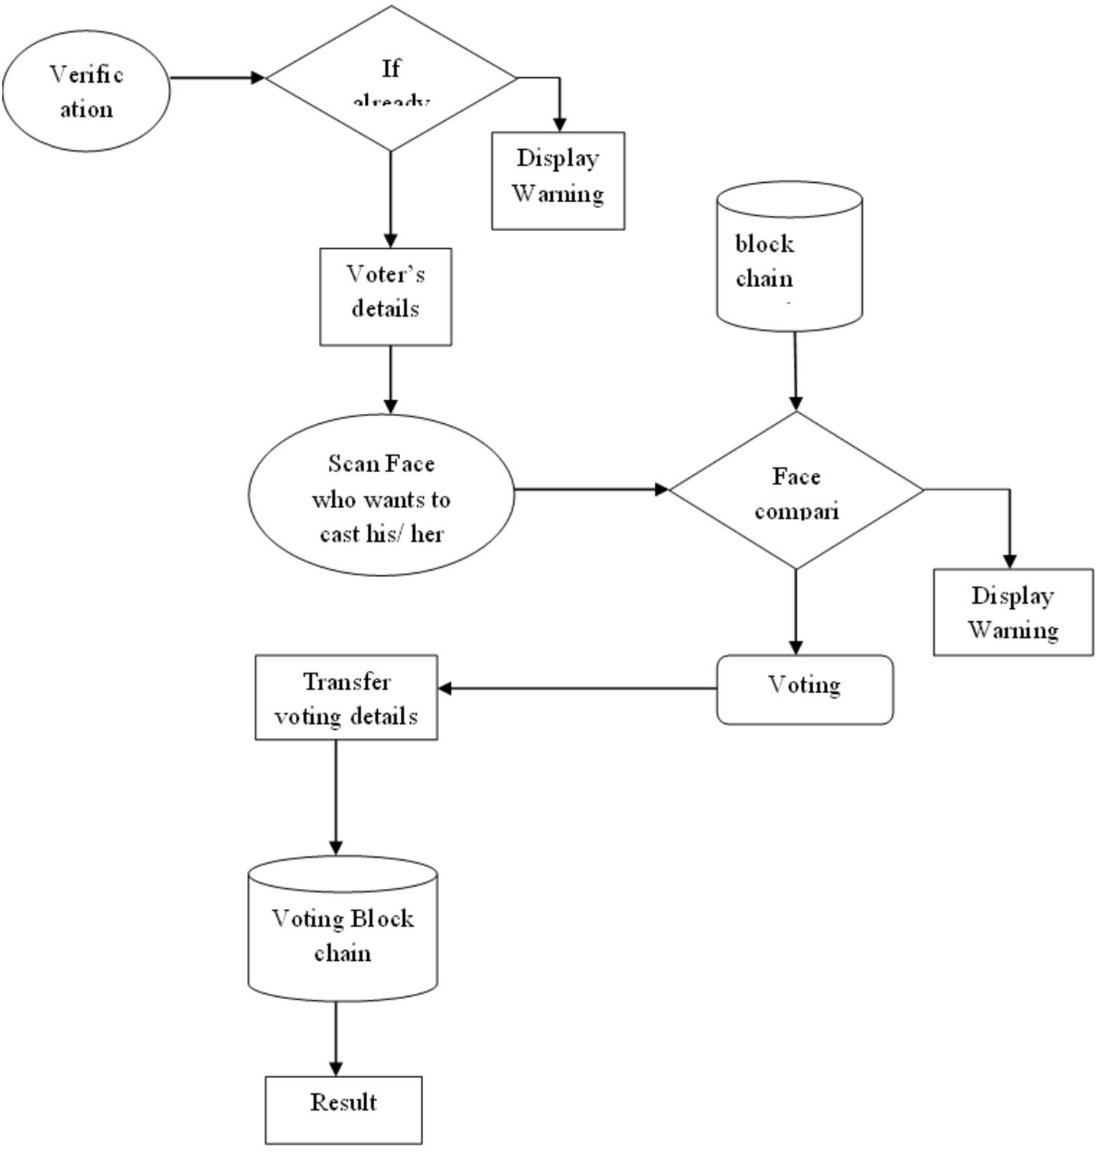

***Fig. 4.3.4: DFD Level 3 for e-Voting System***

SSJCET, Asangaon 26 Department of Computer Engg.

A Framework To Make Voting System Transparent Using Block Chain Technology

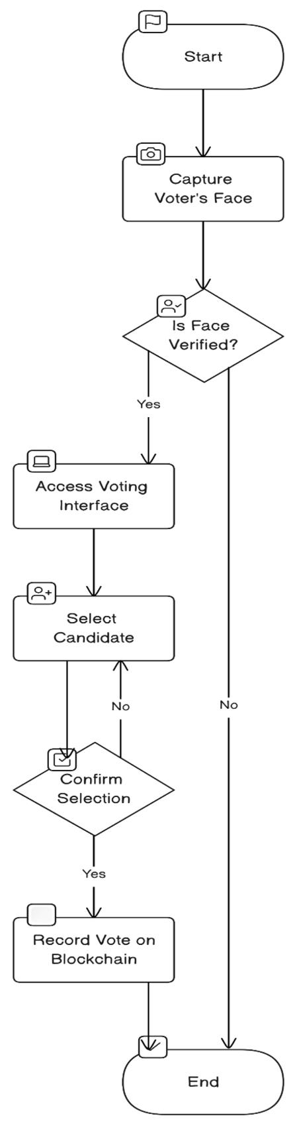

**4.4 FLOW CHART**

***Fig. 4.4: Flowchart of e-Voting System***

SSJCET, Asangaon 27 Department of Computer Engg.

A Framework To Make Voting System Transparent Using Block Chain Technology

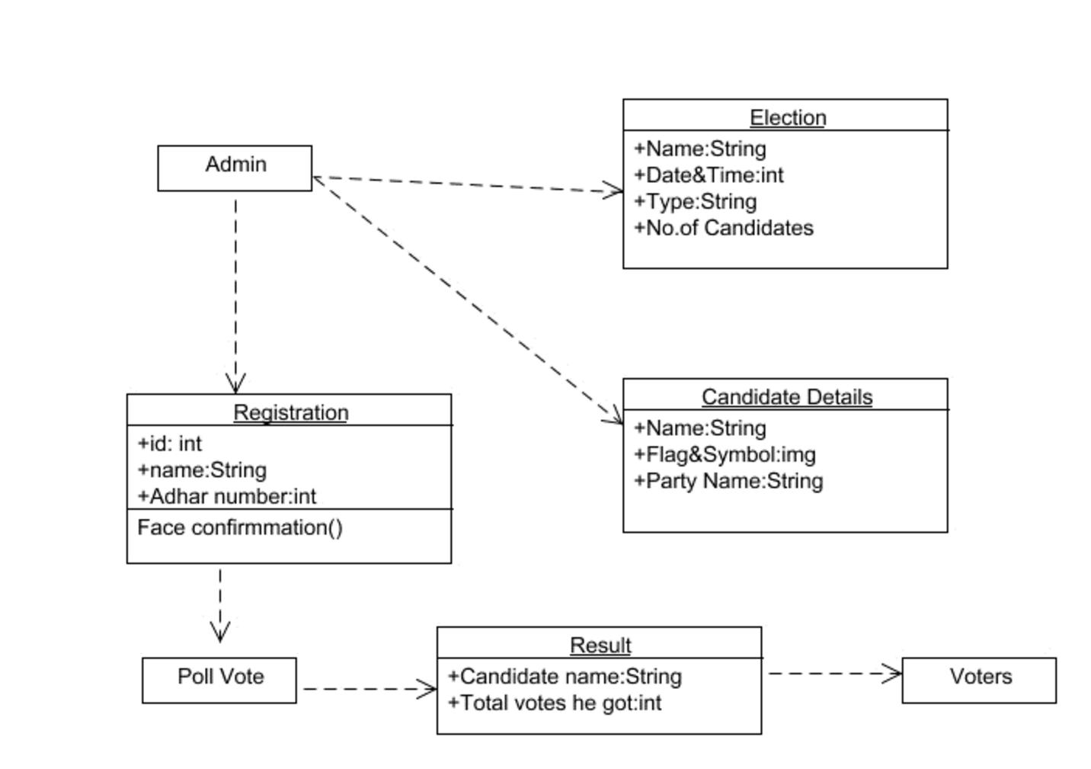

**4.5 UML DIAGRAMS**

**4.5.1 CLASS DIAGRAM**

***Fig. 4.5.1 Class Diagram for e-Voting System***

SSJCET, Asangaon 28 Department of Computer Engg.

A Framework To Make Voting System Transparent Using Block Chain Technology

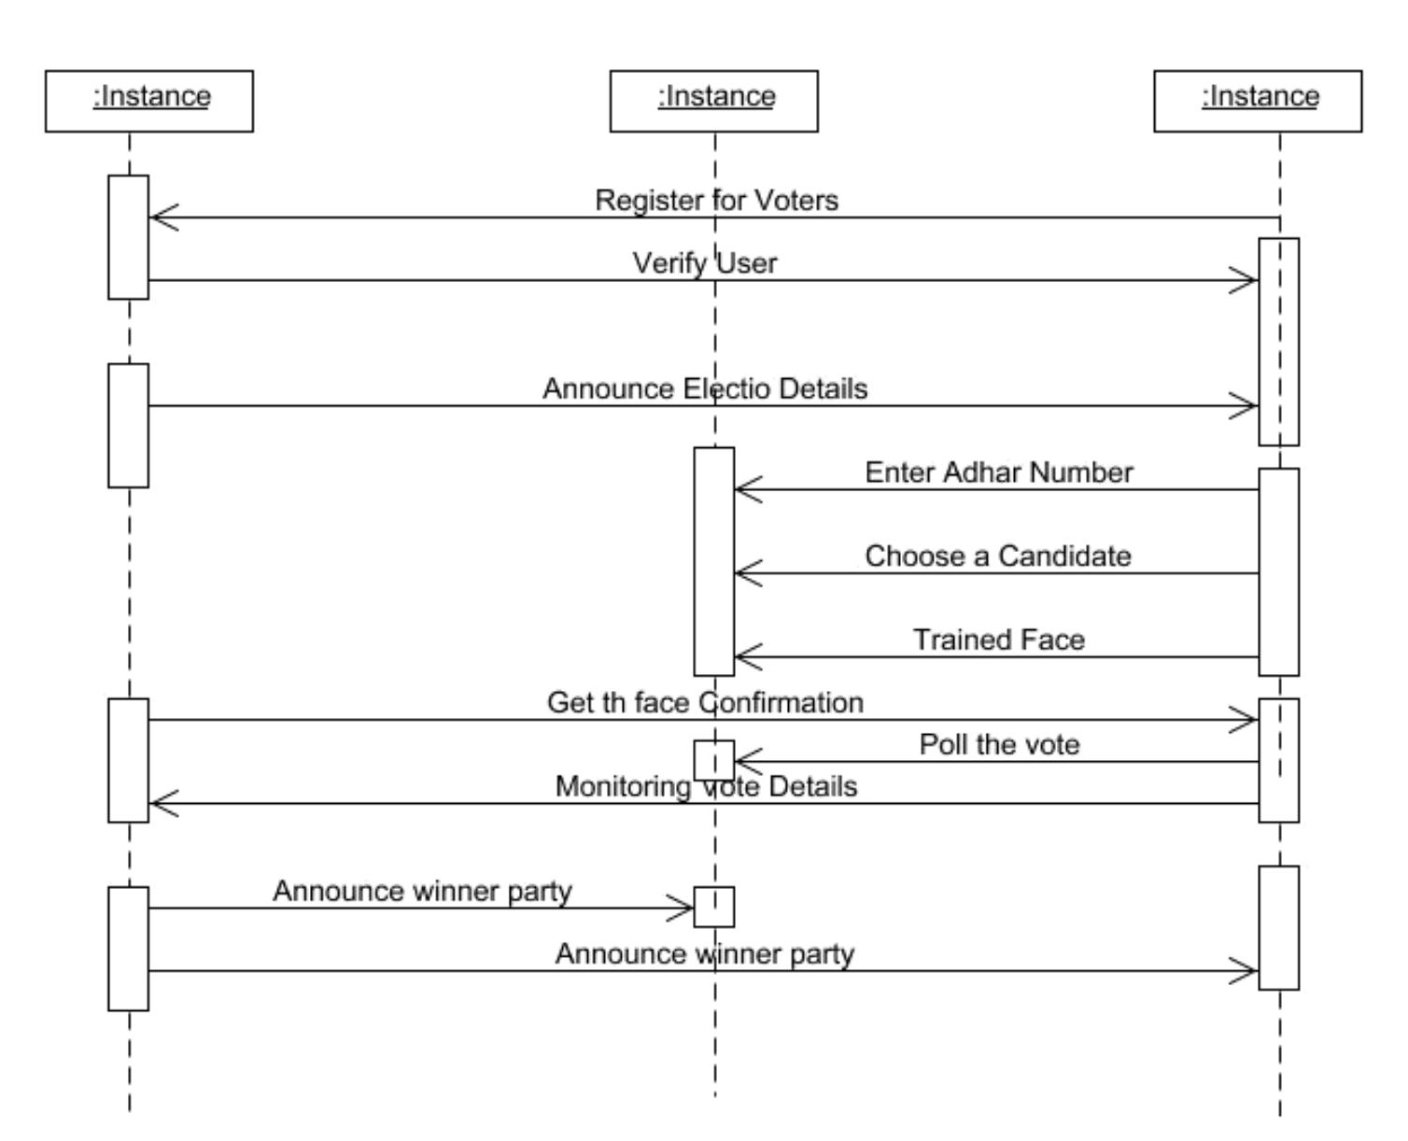

**4.5.2 SEQUENCE DIAGRAM**

***Fig. 4.5.2 Sequence Diagram for e-Voting System***

SSJCET, Asangaon 29 Department of Computer Engg.

A Framework To Make Voting System Transparent Using Block Chain Technology

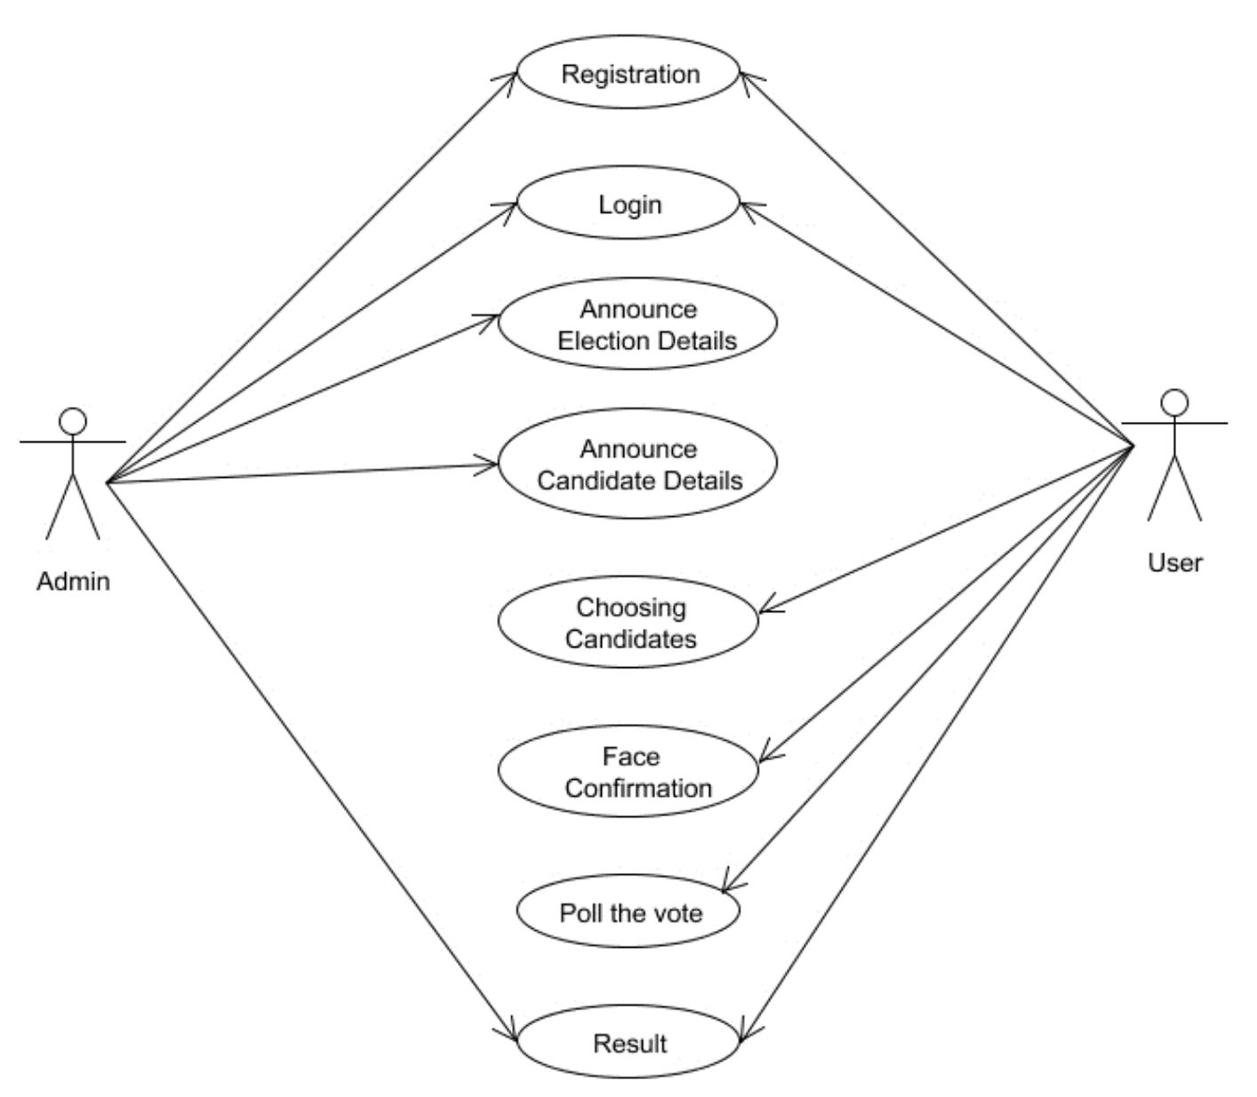

**4.5.3 Use Case Diagram**

***Fig. 4.5.3 Use Case Diagram for e-Voting System***

SSJCET, Asangaon 30 Department of Computer Engg.

A Framework To Make Voting System Transparent Using Block Chain Technology

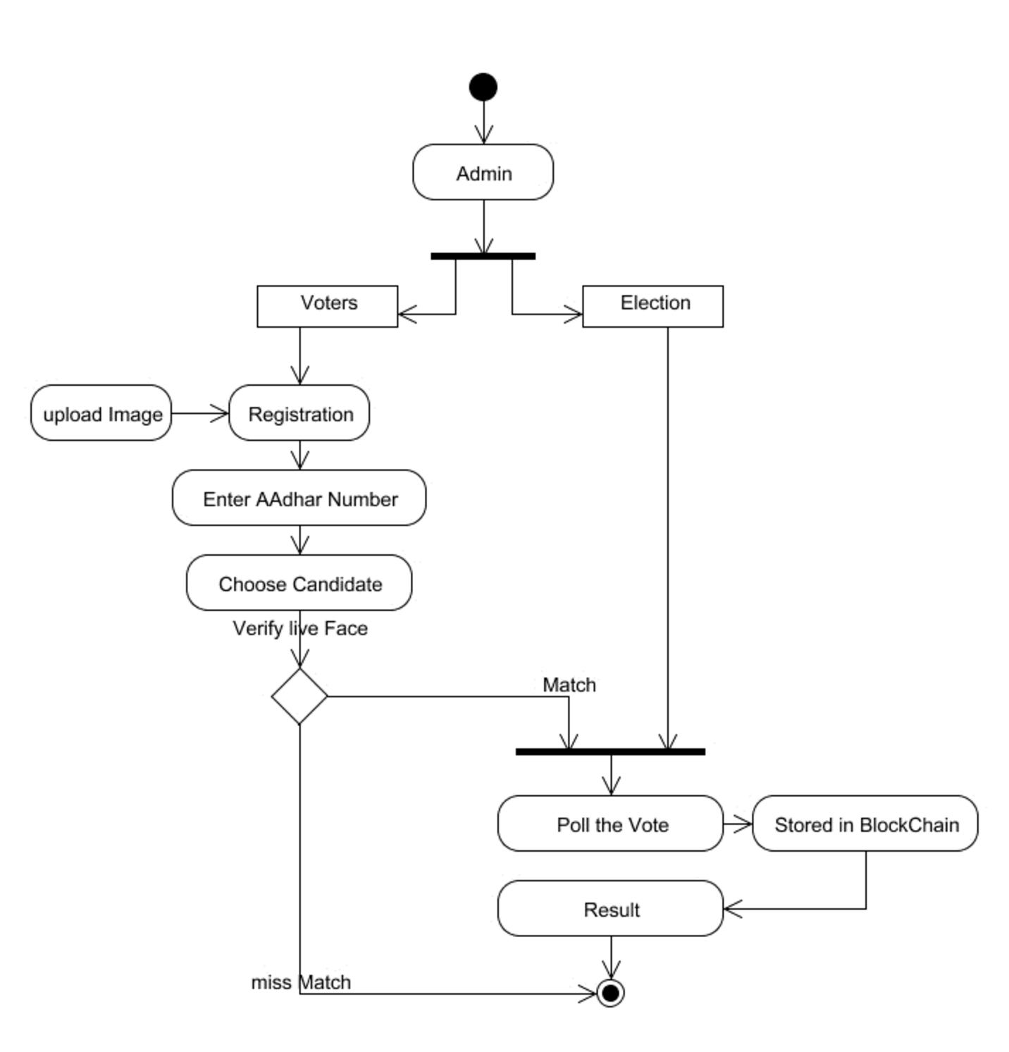

**4.5.4 ACTIVITY DIAGRAM**

***Fig. 4.5.4 Activity Diagram e-Voting System***

SSJCET, Asangaon 30 Department of Computer Engg.

A Framework To Make Voting System Transparent Using Block Chain Technology

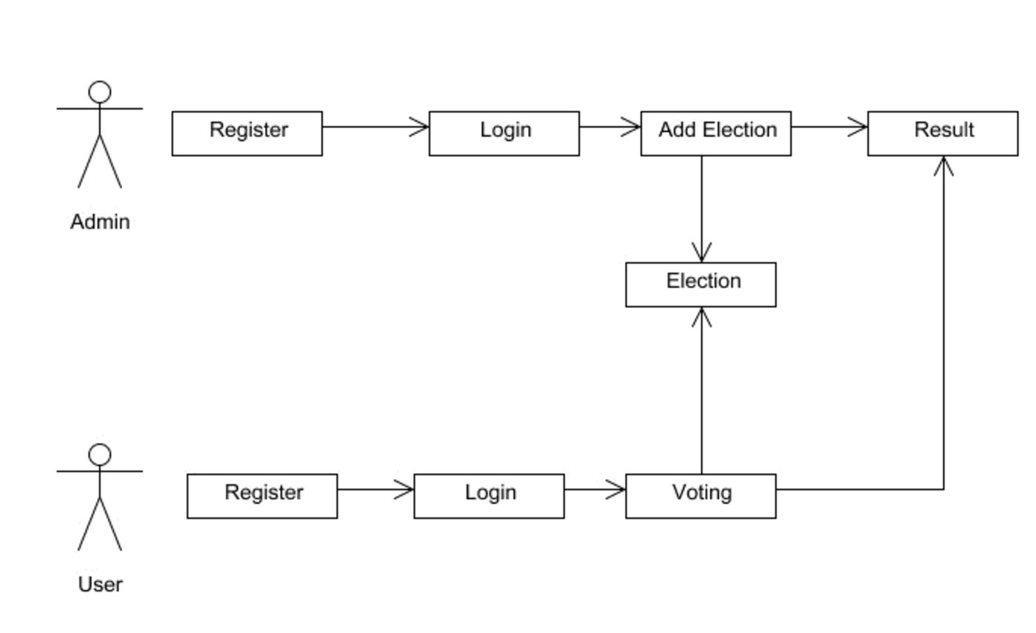

**4.5.5 COLLABORATION DIAGRAM**

***Fig. 4.5.5 Collaboration Diagram for e-Voting System***

SSJCET, Asangaon 31 Department of Computer Engg.

**PROJECT**

**IMPLEMENTATION**

A Framework To Make Voting System Transparent Using Block Chain Technology



**5. PROJECT IMPLEMENTATION**

**5.1 TECHNOLOGY OVERVIEW**

**PYTHON**

Python is a general-purpose interpreted, interactive, object-oriented, and high-level

programming language. An interpreted language, Python has a design philosophy that

emphasizes code readability (notably using whitespace indentation to delimit code blocks

rather than curly brackets or keywords), and a syntax that allows programmers to express

concepts in fewer lines of code than might be used in languages such as C++ or Java. It

provides constructs that enable clear programming on both small and large scales. Python

interpreters are available for many operating system. CPython, the reference

implementation of Python, is open-source software and has a community-based

development model, as do nearly all of its variant implementations. CPython is managed by

the non-profit python software foundation. Python features a dynamic type system and

automatic memory management. It supports multiple programming paradigms, including

object oriented , imperative, functional and procedural, and has a large and comprehensive

standard library.

**Bloch-chain**

Blockchain is a distributed ledger technology that enables secure, transparent, and

immutable record-keeping of transactions across a network of computers. Each block in the

chain contains a number of transactions, and every time a new transaction occurs, a record

of that transaction is added to every participant’s ledger.

Key Features:

Decentralization: Unlike traditional centralized systems where a single authority controls

the data, blockchain operates on a decentralized network of computers (nodes). This

eliminates the need for a central authority, making the system more resilient and less prone

to manipulation.

Transparency: The entire transaction history is recorded on a public ledger that is

accessible to all participants. This transparency helps to build trust among users as they can

verify the authenticity of transactions.

SSJCET, Asangaon 32 Department of Computer Engg.

A Framework To Make Voting System Transparent Using Block Chain Technology

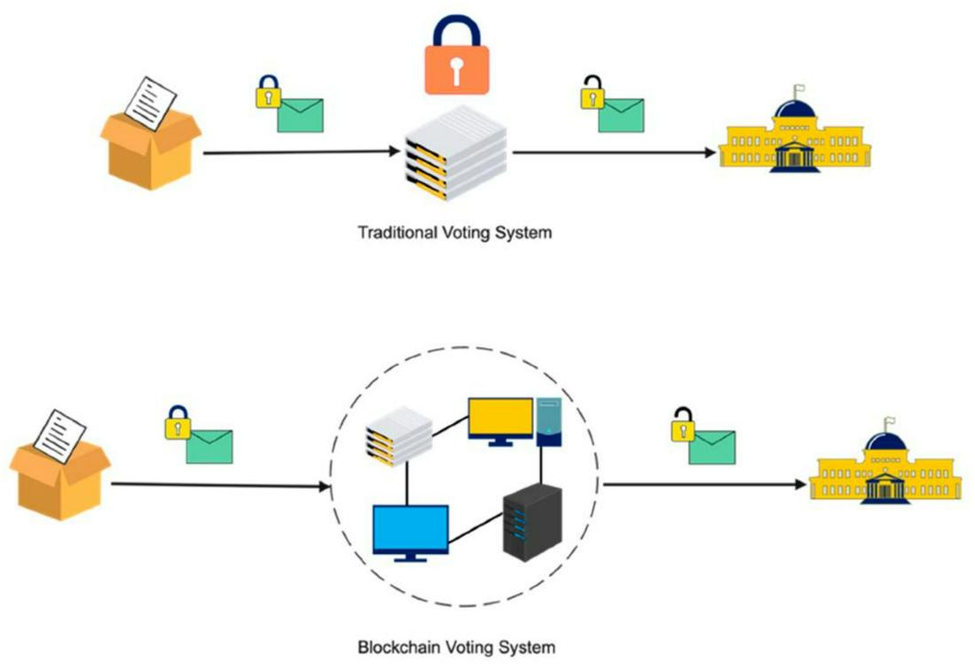

Immutability: Once a transaction is recorded on the blockchain, it cannot be altered or

deleted. Each block contains a unique cryptographic hash of the previous block, making it

extremely difficult to tamper with historical data without the consensus of the majority of

participants.

Security: Blockchain uses cryptographic techniques to secure transactions and protect the

integrity of the network. Each participant has a private key to sign transactions, and

consensus mechanisms ensure that only valid transactions are added to the ledger.

Types of Blockchain:

Public Blockchain: Anyone can participate in a public blockchain network, and the data is

accessible to anyone. Bitcoin and Ethereum are examples of public blockchains.

Private Blockchain: In a private blockchain, access is restricted to a specific group of

participants. It is often used by businesses and organizations to maintain privacy and control

over the network.

Consortium Blockchain: A consortium blockchain is controlled by a group of organizations

rather than a single entity. It offers a balance between the openness of public blockchains

and the control of private blockchains.

SSJCET, Asangaon 33 Department of Computer Engg.

A Framework To Make Voting System Transparent Using Block Chain Technology



**5.2 CODING**

**face_recognition_knn_web.py**

import os

import json

from math import sqrt

#from sklearn import neighbors

from sklearn.neighbors import KNeighborsClassifier

from os import listdir

from os.path import isdir, join, isfile, splitext

import pickle

from PIL import Image, ImageFont, ImageDraw, ImageEnhanceimport face_recognition

from face_recognition import face_locationsfrom face_recognition.cli import image_files_in_folder#This is not working for me

#from face_recognition.face_recognition_cli import image_files_in_folder#comment this line if you got error

from flask import Flask, jsonify, request, redirect,render_templatefrom flask_cors import CORS

from os import path

ALLOWED_EXTENSIONS = {'png', 'jpg', 'jpeg'}REGISTER_PATH="./Register/" TEMP_PATH="./Temp/"

if not os.path.exists(REGISTER_PATH): os.makedirs(REGISTER_PATH )

app = Flask(__name__)

CORS(app)

def allowed_file(filename):

return '.' in filename and \

filename.rsplit('.', 1)[1].lower() in ALLOWED_EXTENSIONS@app.route('/register', methods=['GET', 'POST'])

SSJCET, Asangaon 34 Department of Computer Engg.

A Framework To Make Voting System Transparent Using Block Chain Technology



def upload_register():

# Check if a valid image file was uploaded

if request.method == 'POST':

if 'file' not in request.files:

return json.dumps({"status": "Error", "msg": "Image cannot be empty "})

name = request.form.get('name')

email = request.form.get('email')

if(name ==''):

return json.dumps({"status": "Error", "msg": "Name cannot be empty "})

file = request.files['file']

# src = path.realpath(REGISTER_PATH+"/"+email+"/"+name+"/"+file.filename)

print(name)

print(file)

if file.filename == '':

return json.dumps({"status": "Error", "msg": "Image cannot be empty "})

if file and allowed_file(file.filename):

if os.path.exists(REGISTER_PATH+email):

#file.save(REGISTER_PATH+email+"/"+file.filename)

foo = Image.open(file)

#foo = foo.rotate(90, PIL.Image.NEAREST, expand = 1)

foo.save(REGISTER_PATH+email+"/"+file.filename.strip(),optimize=True,quality=85)

os.rename(REGISTER_PATH+email+"/"+file.filename,REGISTER_PATH+email+"/"+na

me+".jpg")

#return json.dumps({"status": "Error", "msg": "User Already Registered"})

else:

SSJCET, Asangaon 35 Department of Computer Engg.

A Framework To Make Voting System Transparent Using Block Chain Technology



os.makedirs(REGISTER_PATH+email)

foo = Image.open(file)

#file.save(REGISTER_PATH+email+"/"+file.filename)

#foo = foo.rotate(90, PIL.Image.NEAREST, expand = 1)

foo.save(REGISTER_PATH+email+"/"+file.filename.strip(),optimize=True,quality=85)

os.rename(REGISTER_PATH+email+"/"+file.filename,REGISTER_PATH+email+"/"+na

me+".jpg")

print(file)

return json.dumps(train(REGISTER_PATH))

else:

return json.dumps({"status": "Error", "msg": "Image Format not supported

<png,jpg,jpeg> "})

# If no valid image file was uploaded, show the file upload form:

return json.dumps ({"status":"Error","msg":"GET Not Allowed "})

@app.route('/', methods=['GET', 'POST'])

def upload_image():

# Check if a valid image file was uploaded

if request.method == 'POST':

if 'file' not in request.files:

return redirect(request.url)

file = request.files['file']

if file.filename == '':

return redirect(request.url)

foo = Image.open(file)

if file and allowed_file(file.filename):

# The image file seems valid! Detect faces and return the result.

SSJCET, Asangaon 36 Department of Computer Engg.

A Framework To Make Voting System Transparent Using Block Chain Technology



print(file)

#foo = foo.rotate(90, PIL.Image.NEAREST, expand = 1)

foo.save(TEMP_PATH+"/"+file.filename.strip(),optimize=True,quality=85)

return json.dumps(predict(file))

# If no valid image file was uploaded, show the file upload form:

return render_template('index.html')

def predict(X_img_path, knn_clf = None, model_save_path ="train", DIST_THRESH = .5):

# if not isfile(X_img_path) or splitext(X_img_path)[1][1:] not in

ALLOWED_EXTENSIONS:

# raise Exception("invalid image path: {}".format(X_img_path))

if knn_clf is None:

with open(model_save_path, 'rb') as f:

knn_clf = pickle.load(f)

# X_img = face_recognition.load_image_file(X_img_path)

#X_img = face_recognition.load_image_file(X_img_path)

X_img = face_recognition.load_image_file(TEMP_PATH+X_img_path.filename)

X_faces_loc = face_locations(X_img)

if len(X_faces_loc) == 0:

return []

faces_encodings = face_recognition.face_encodings(X_img,

known_face_locations=X_faces_loc)

closest_distances = knn_clf.kneighbors(faces_encodings, n_neighbors=1)

is_recognized = [closest_distances[0][i][0] <= DIST_THRESH for i in

range(len(X_faces_loc))]

return [{"result":pred,"status":str(rec)} if rec else {"result":"N/A","status":str(rec)} for

pred, loc, rec in zip(knn_clf.predict(faces_encodings), X_faces_loc, is_recognized)]

def train(train_dir, model_save_path="train", n_neighbors=None, knn_algo='ball_tree',

verbose=False):

X = []

y = []

for class_dir in listdir(train_dir):

SSJCET, Asangaon 37 Department of Computer Engg.

A Framework To Make Voting System Transparent Using Block Chain Technology



if not isdir(join(train_dir, class_dir)):

continue

for img_path in image_files_in_folder(join(train_dir, class_dir)):

image = face_recognition.load_image_file(img_path)

faces_bboxes = face_locations(image)

if len(faces_bboxes) != 1:

if verbose:

print("image {} not fit for training: {}".format(img_path, "didn't find a face" if

len(

faces_bboxes) < 1 else "found more than one face"))

continue

X.append(face_recognition.face_encodings(image,

known_face_locations=faces_bboxes)[0])

y.append(class_dir)

if n_neighbors is None:

n_neighbors = int(round(sqrt(len(X))))

if verbose:

print("Chose n_neighbors automatically as:", n_neighbors)

#knn_clf = neighbors.KNeighborsClassifier(n_neighbors=n_neighbors,

algorithm=knn_algo, weights='distance')

knn_clf = KNeighborsClassifier(n_neighbors=n_neighbors, algorithm=knn_algo,

weights='distance')

knn_clf.fit(X, y)

if model_save_path != "":

with open(model_save_path, 'wb') as f:

pickle.dump(knn_clf, f)

return {"status":"Success","msg":"Trained successfully"}

if __name__ == "__main__":

app.run(host='0.0.0.0', port=5001, debug=True)

SSJCET, Asangaon 38 Department of Computer Engg.

**TESTING**

A Framework To Make Voting System Transparent Using Block Chain Technology



**6. TESTING**

**6.1 SYSTEM TESTING**

***Table no. 6.1: Test Cases***

**Sr no. Test Case Expected Result Result Remark (if fail)**

|  |  |  |  |  |  |  |  |  |  |  |  |  |  |  |  |  |  |  |  |  |  |  |  |  |  |  |  |  |  |  |  |  |  |  |  |  |  |  |  |  |  |
| --- | --- | --- | --- | --- | --- | --- | --- | --- | --- | --- | --- | --- | --- | --- | --- | --- | --- | --- | --- | --- | --- | --- | --- | --- | --- | --- | --- | --- | --- | --- | --- | --- | --- | --- | --- | --- | --- | --- | --- | --- | --- |
|  | 1 User Register | | | | | | | | | | | |  | | If User registration  successfully. Pass | | | | | | | | | | | |  | | | If already user  email exist, then  it fails. | | | | | | | | | | | |
|  | 2 User Login | | | | | | |  | If Username and  password is correct,  then it will getting  valid page. | | | | | | | | | | | | | |  | | Pass | | | | | | | | |  | Un Register  Users will not  logged in. | | | |
|  | 3 Admin login | | | | | | | | | | | | | | | |  | | Admin can login  with his login  credential. If  success he get his  home page | | |  | | Pass | | | | | | | |  | Invalid login  details will not  allowed here | | | | | | |
|  | 4 |  | Admin can  activate the  register users | | | | | | |  | | Admin can activate  the register user id | | | | | | | | | |  | | Pass | | | | | | | | | | | |  | If user id not  found then it  won’t login |
|  | 7 | | | | |  | Blockchain  public  Address | | | | | | | | |  | | Obtaining Unique  Hash value | | | | |  | | Pass |  | | Receiving  Unique Hash  Value using  Blockchain from  Ganache Server | | | | | | | | | | | | | | | |
|  | 5 | | |  | Face  Recognition | | | | | | | | | | | | | | |  | If face is  Recognised Pass | | | | | | | |  | | If Face is not  Valid then voter  cannot cast vote | | | | | | | | | |
|  | 6 |  | Input Aadhar  Feed by the  user | | | | | | | |  | | | Valid Aadhar  number is accepted  as enrolled in  Database | | | | | | | |  | | Pass Invalid User Not  Allowed | | | | | | | | | | | | | | | | | | |

SSJCET, Asangaon 39 Department of Computer Engg.

**RESULTS AND DISCUSSIONS**

A Framework To Make Voting System Transparent Using Block Chain Technology



**7. RESULTS AND DISCUSSIONS- 7.1 RESULTS SETS**

***TABLE 7.1.1 TESTING PERFORMANCE ON TRAIN SET***

Testing with k = 1

**Test Precision Recall Fl-score Support**

A 1.0 0.50 0.67 2.00

B 0.67 1.00 0.80 2.00

C 1.0 1.00 1.0 2.00

D 0.67 1.00 0.80 2.00

E 1.0 0.50 0.67 2.00

F 0.67 1.00 0.80 2.00

G 1.0 1.00 1.0 2.00

H 1.00 0.50 0.67 2.00

I 1.00 1.0 1.0 2.00

H 0.50 1.00 0.67 2.00

K 1.0 0.50 0.67 2.00

L 1.0 1.00 1.0 2.00

M 0.50 0.50 0.50 2.00

N 1.0 1.00 1.0 2.00

O 1.0 1.00 1.0 2.00

P 0.33 0.50 0.40 2.00

Q 0.67 1.0 0.80 2.00

R 1.0 1.0 1.0 2.00

S 1.0 1.0 1.0 2.00

T 0.50 1.0 0.67 2.00

**Average 0.83 0.85 0.81 2.00**

SSJCET, Asangaon 40 Department of Computer Engg.

A Framework To Make Voting System Transparent Using Block Chain Technology



***TABLE7.1.2 TESTING PERFORMANCE ON VALIDATION SET***

Testing with k = 2

**Test Precision Recall Fl-score Support**

A 0.33 0.5 0.4 2

B 0.5 0.5 0.5 2

C 0.5 1 0.67 2

D 0.33 0.5 0.4 2

E 0.33 0.5 0.4 2

F 0.5 1.0 0.67 2

G 1.0 1.0 1.0 2

H 1.0 1.0 1.0 2

I 0.67 1.0 0.8 2

H 0.5 1.0 0.67 2

K 0 0 0 2

L 0.25 0.5 0.33 2

M 1.0 0.5 0.67 2

N 1.0 0.5 0.67 2

O 1.0 0.5 0.67 2

P 0.5 1.0 0.67 2

Q 0.67 1.0 0.8 2

R 0 0 0 2

S 0 0 0 2

T 0 0 0 2

**Average 0.504 0.6 0.516 2**

SSJCET, Asangaon 41 Department of Computer Engg.

A Framework To Make Voting System Transparent Using Block Chain Technology



***TABLE7.1.3 TESTING PERFORMANCE ON VALIDATION SET***

Testing with k = 3

**Test Precision Recall Fl-score Support**

A 0.67 1.0 0.8 2

B 1.0 1.0 1.0 2

C 0.5 1.0 0.67 2

D 0 0 0 2

E 0.33 0.5 0.4 2

F 0.33 1.0 0.5 2

G 1.0 0.5 0.67 2

H 1.0 0.5 0.67 2

I 0.5 1.0 0.67 2

H 0.25 0.5 0.33 2

K 0 0 0 2

L 0.33 0.5 0.4 2

M 1.0 0.5 0.67 2

N 1.0 0.5 0.67 2

O 1.0 1.0 1.0 2

P 0.33 0.5 0.4 2

Q 0.33 0.5 0.4 2

R 0 0 0 2

S 0 0 0 2

T 0.5 0.5 0.5 2

**Average 0.5035 0.55 0.4875 2**

SSJCET, Asangaon 42 Department of Computer Engg.

A Framework To Make Voting System Transparent Using Block Chain Technology

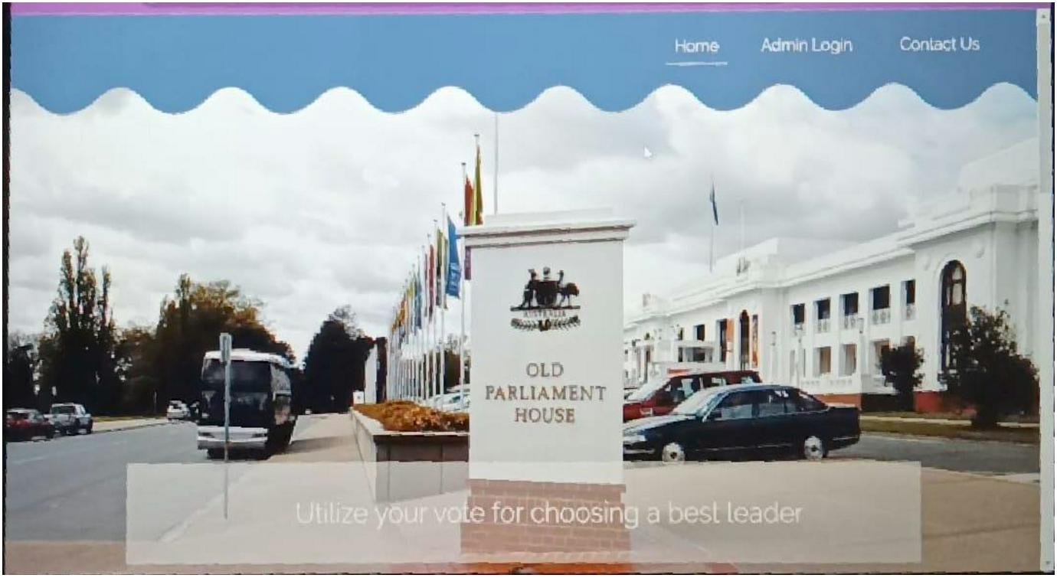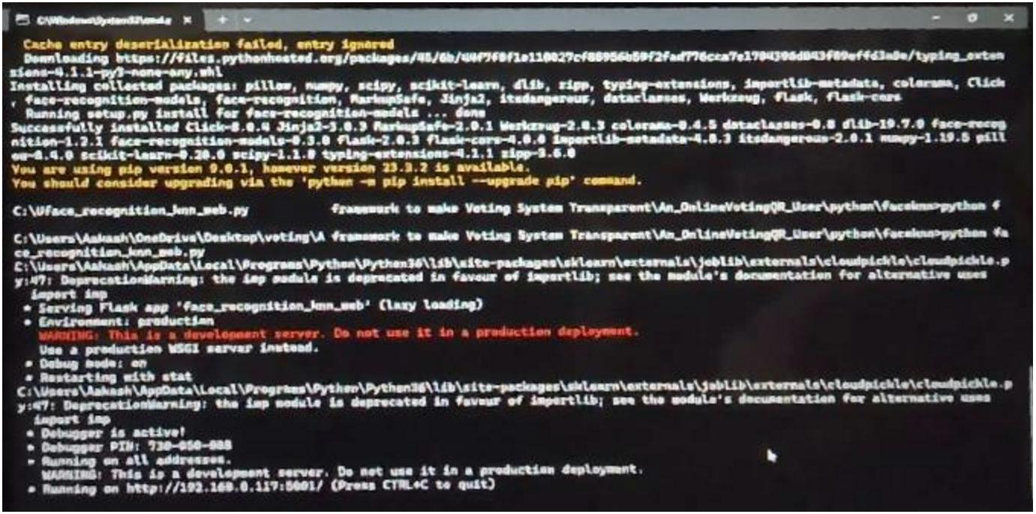

**7.2 SCREENSHOTS**

***Fig.7.2.1: Home Page***

***Fig.7.2.2: Face verification***

SSJCET, Asangaon 43 Department of Computer Engg.

A Framework To Make Voting System Transparent Using Block Chain Technology

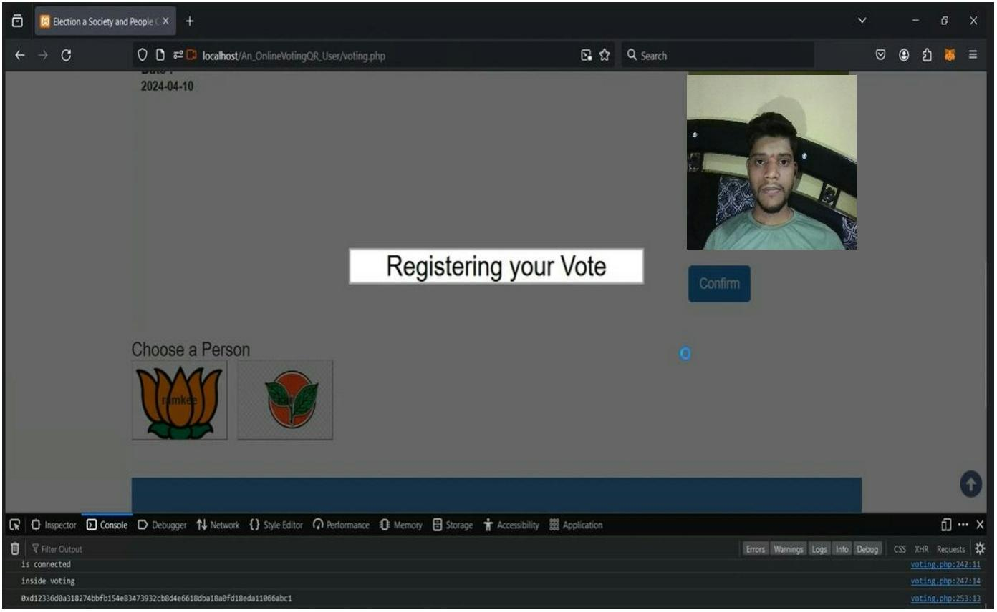

***Fig.7.2.3: Caste Vote***

SSJCET, Asangaon 44 Department of Computer Engg.

**ADVANTAGES**

A Framework To Make Voting System Transparent Using Block Chain Technology



**8. ADVANTAGES**

➢ Helps solve advanced real-world issues with many constraints.

➢ Voters can cast their votes from anywhere in the country without visiting to voting booths,

in highly secured way.

➢ This will increase the voting percentage in India and reduces the cost of voting process.

➢ Provides a path towards achieving Artificial General Intelligence sometime within the

future.

➢ By using Face Verification, it provides enough security which reduces the false votes.

➢ The collection of the results is done from the stored data on the blocks through the

significant organization of the nodes in the block chain.

SSJCET, Asangaon 55 Department of Computer Engg.

**CONCLUSION**

A Framework To Make Voting System Transparent Using Block Chain Technology



**CONCLUSION**

Thus, we have tried to implement the paper “Muhammad Shoaib Farooq, Usman Iftikhar,

And Adel Khelifi" A Framework to Make Voting System Transparent Using Blockchain

Technology " 2022 IEEE Access and the conclusion is as follows While e-voting on the

blockchain with KNN and SHA-256 offers significant advantages in terms of security and

transparency the fusion of blockchain technology, KNN, and SHA-256 encryption holds great

promise for revolutionizing the electoral process, making it more reliable, resilient, translucent,

and digitally relevant.

SSJCET, Asangaon 56 Department of Computer Engg.

**FUTURE WORK**

A Framework To Make Voting System Transparent Using Block Chain Technology



**FUTURE WORK**

Block chain-based voting, which relies on a decentralized, distributed digital ledger is

vulnerable to many of the security flaws inherent in internet voting, such as the potential for

malware to alter votes on a voter’s local device before the ballot is transmitted and the lack

of secret ballots.

SSJCET, Asangaon 57 Department of Computer Engg.

**REFERENCES**

**APPENDIX**

**REFERENCES**

[1] M. S. Farooq, U. Iftikhar and A. Khelifi, "A Framework to Make Voting System Transparent Using Blockchain Technology," in IEEE Access, vol. 10, pp. 59959-59969, 2022, doi: 10.1109/ACCESS.2022.3180168.

[2] A. Parmar, S. Gada, T. Loke, Y. Jain, S. Pathak and S. Patil, "Secure E-Voting System using Blockchain technology and authentication via Face recognition and Mobile OTP," 2021 12th International Conference on Computing Communication and Networking Technologies (ICCCNT), Kharagpur, India, 2021, pp. 1-5, doi: 10.1109/ICCCNT51525.2021.9580147.

[3] M. S. Farooq, M. Khan, and A. Abid, ‘‘A framework to make charity collection transparent and auditable using blockchain technol- ogy,’’ Comput. Electr. Eng., vol. 83, May 2020, Art. no. 106588, doi:10.1016/j.compeleceng.2020.106588.

[4] B. Shahzad and J. Crowcroft, ``Trustworthy electronic voting using adjusted blockchain technology,'' IEEE Access, vol. 7, pp. 47724488, 2019,s doi: 10.1109/ACCESS.2019.2895670.

[5] N. M. Crosby, P. Pattanayak, S. Verma, andV. Kalyanaraman, “Blockchain technology Beyond bitcoin,” Sutardja Center Entrepreneurship Technol., Univ. California, Berkeley, CA, USA, Tech. Rep., Oct. 2015. Accessed: Jan. 24, 2018. [Online].

[6] K. M. Khan, J. Arshad, and M. M. Khan, ``Secure digital voting system based on blockchain technology,'' Int. J. Electron. Government Res., vol. 14, no. 1, pp. 5362, Jan. 2018, doi .4018/IJEGR.2018010103.

[7] F.P. Hjalmarsson, G. K. Hreidarsson, M. Hamdaqa and G. Hjálmtýsson, "Blockchain-Based E-Voting System," 2018 IEEE 11th International Conference on Cloud Computing (CLOUD), San Francisco, CA, USA, 2018, pp. 983-986, doi: 10.1109/CLOUD.2018.00151.

[8] Dadi, Harihara & Mohan, P.G. (2016). Improved Face Recognition Rate Using HOG Features and SVM Classifier. IOSR Journal of Electronics and Communication Engineering (IOSR-JECE). 11. 34-44. 10.9790/2834-1104013444

[9] Satish Jaywant Manje, Sayed Md Rafe, Saini Bhawani Singh, Gaurav Gurav, “Collaborative Filtering Based Recommendation Of Online Social Voting Systems”, IJREAM, ISSN: 2454-9150 Vol-07, Special Issue, MAY 2021.

49

**Appendix**

1) Open the Project path and run one by one.

2) Run Ganache Server for syncing blockchain address.

3) Open Blockchain contracts path and run below command to deploy smart contracts on

local development network:

➔ ‘truffle migrate –network development’

4) Run localhost Xampp Server.

5) Install necessary python libraries using pip.

6) Run Python face_recognition_knn_web.py

7) Python run K-Nearest Neighbour.